Project 5: Short-Term Process Scheduler

Nolan Tuttle & Mathew Hobson
College of Engineering and Technology, Grand Canyon University
CST-315: Operating Systems Lecture and Lab
Professor Citro
April 6, 2025

Summary
This program is an improvement of our previous command-line interpreter program created in Project 3. Our goal with this improved version was to implement a Round-Robin (RR) process scheduler that allocates a time quantum to all running process, preempting each one and moving on to the next after the time quantum has passed until all processes in the queue are completed. We removed the batch file functionality but kept all core features like tokenized inputs, allowing for command separation with semicolons. Each time a command is given by the user to the interpreter, it will add it to the queue and run all processes in the queue, displaying an updated process table for the user to see each time the dispatcher switches processes. An important design choice we made was creating a data structure for each process, that way each process can keep track of its own command (like ‘cd’ or ‘ls’), whether it is finished or not, its process ID, and more. The process table shows all processes running, their id, the name, and the state they are in, which could be running, ready, or blocked. We also added support for the ‘procs’ command, allowing for the -a and ‘-a -si’ options to be specified depending on how the user wants the output sorted. This command will show detailed information about all processes running on the machine, sorted by their id, alphabetically, or unsorted. The program also displays the average turnaround time for each process once they are all finished, allowing for turnaround time analysis and selection of the best time quantum for the situation.
It is important to note that we added 3 demonstration processes that run idly: "sleep 2", "echo idle1 > /dev/null", and "sleep 4". When a command is entered, it will be put at the end of the queue with these commands in front, showing the process table each time a context switch is performed. Also, the ‘procs’ command will run and then exit the program when used.
Code Functionality
Our code consists of 3 key parts: displaying the process states, queueing up a new process, and the RR scheduling algorithm.
- Displaying Process States
  - For this, we simply abstracted out a print method that will show a process ID, name, and status given its index in the process queue.
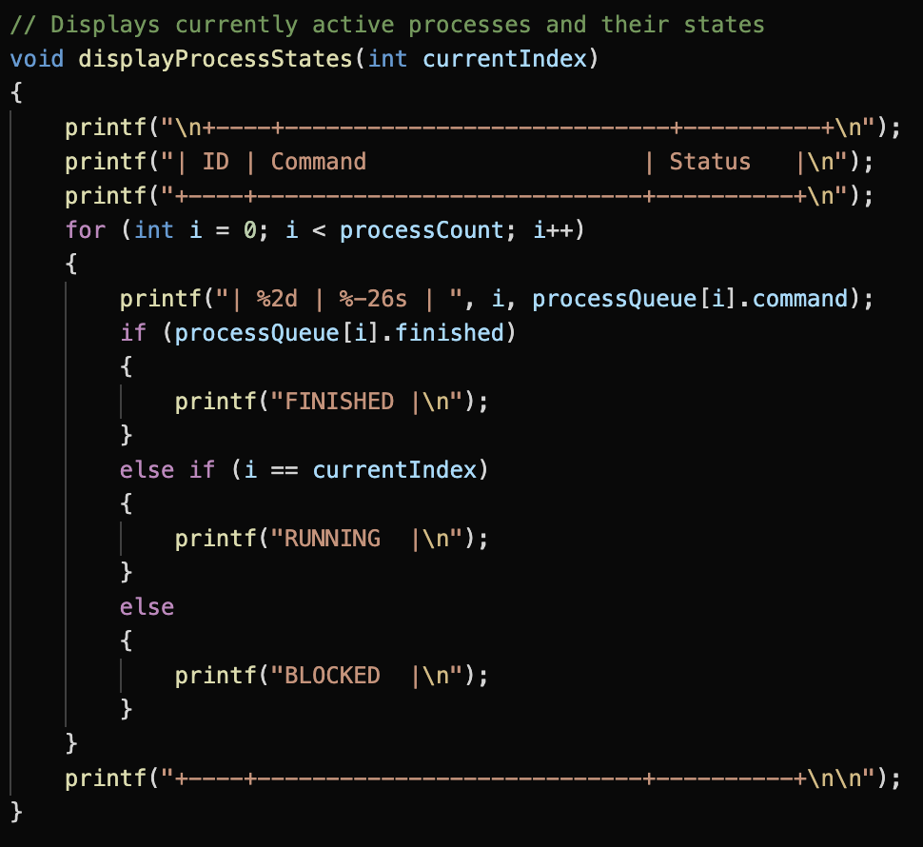
Method for printing out the process states
- Queueing a New Process
  - We abstracted out a method for adding a process to the process queue, simply taking a pointer to an array of characters and updating each of the variables of our Process data structures within the process queue including the actual command string, the finished status, process ID, etc.
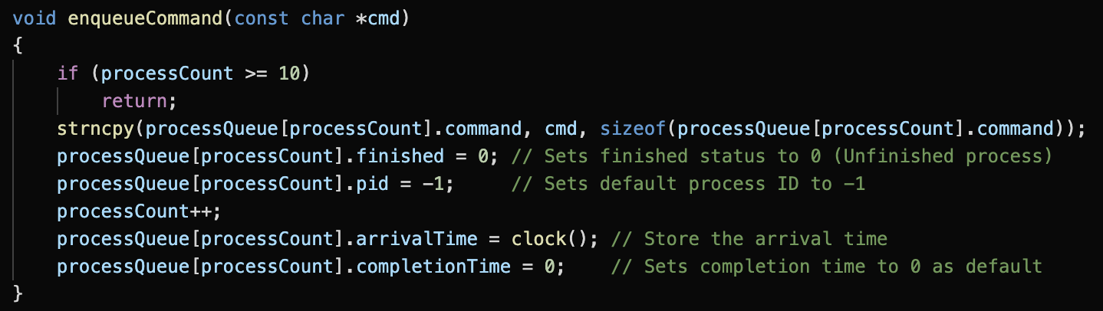
Method for queueing a given command to the process queue.
- Scheduling Algorithm
  - We modified our forking process to create child processes, then immediately pause them and run them in the order of the queue, giving each process a time quantum to use when running.
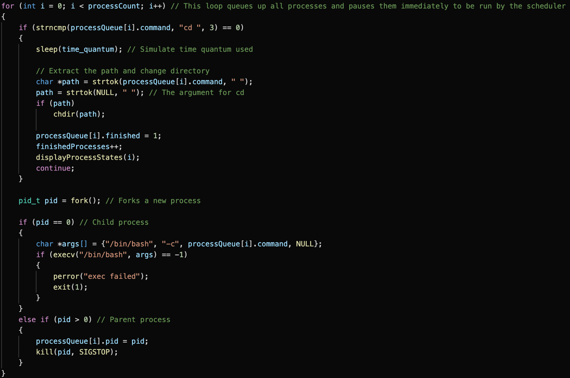
Forking child processes and pausing using kill() as well as logic for changing directory
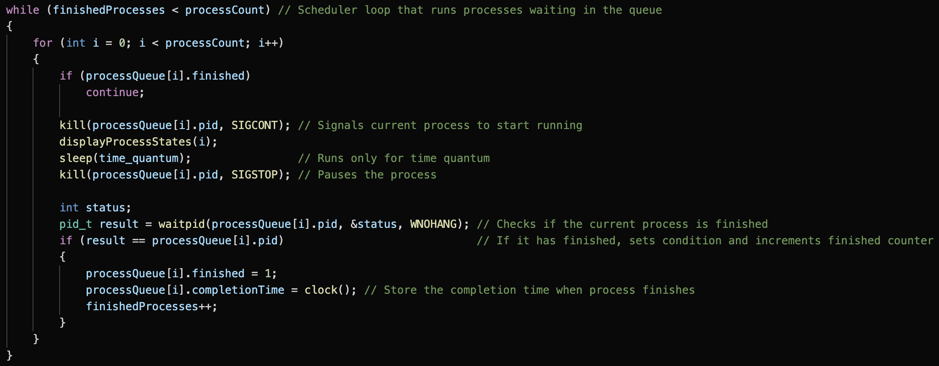
Loop for executing queued up processes, printing the process states and sleeping for the time quantum each iteration until all processes finish

Code Execution
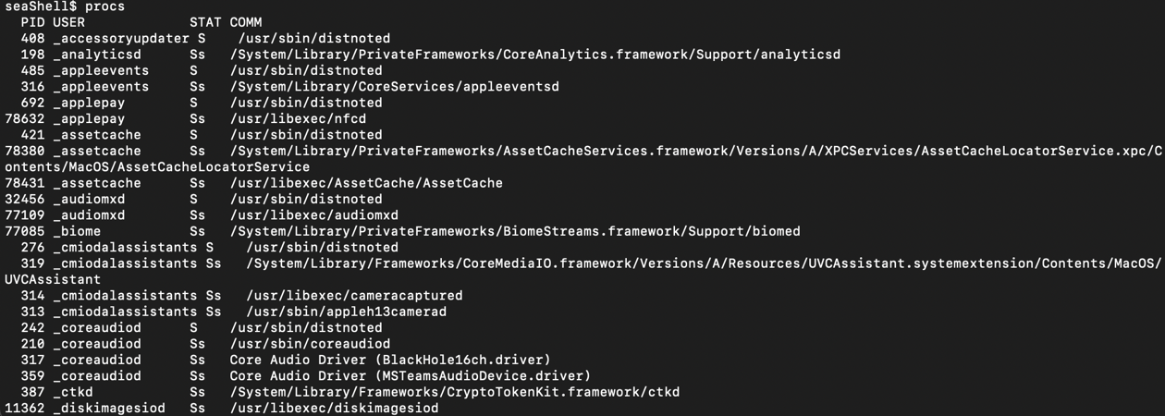
Running the ‘procs’ command
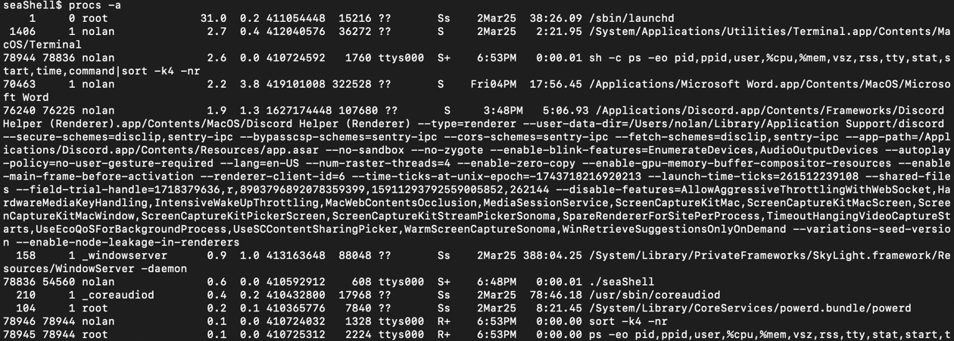
Running the ‘procs’ command with option ‘-a’ specified
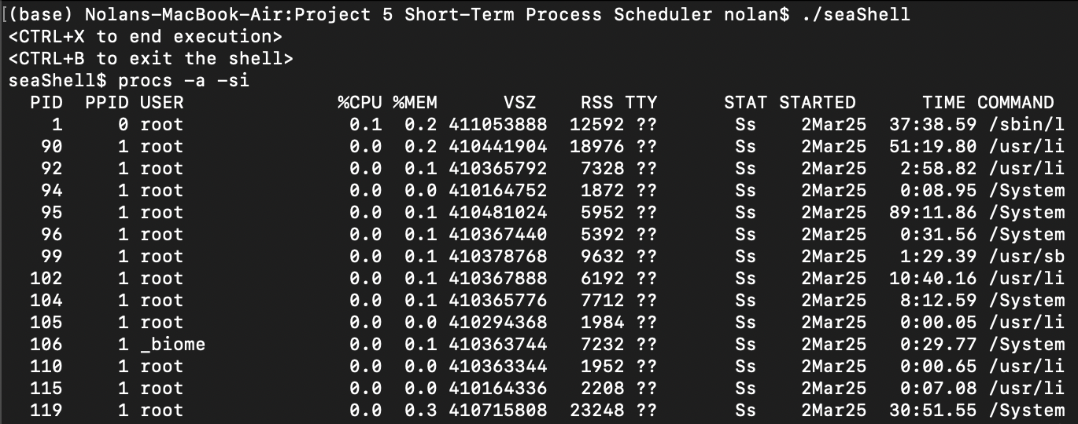
Running the ‘procs’ command with options ‘-a’ and ‘-si’ specified

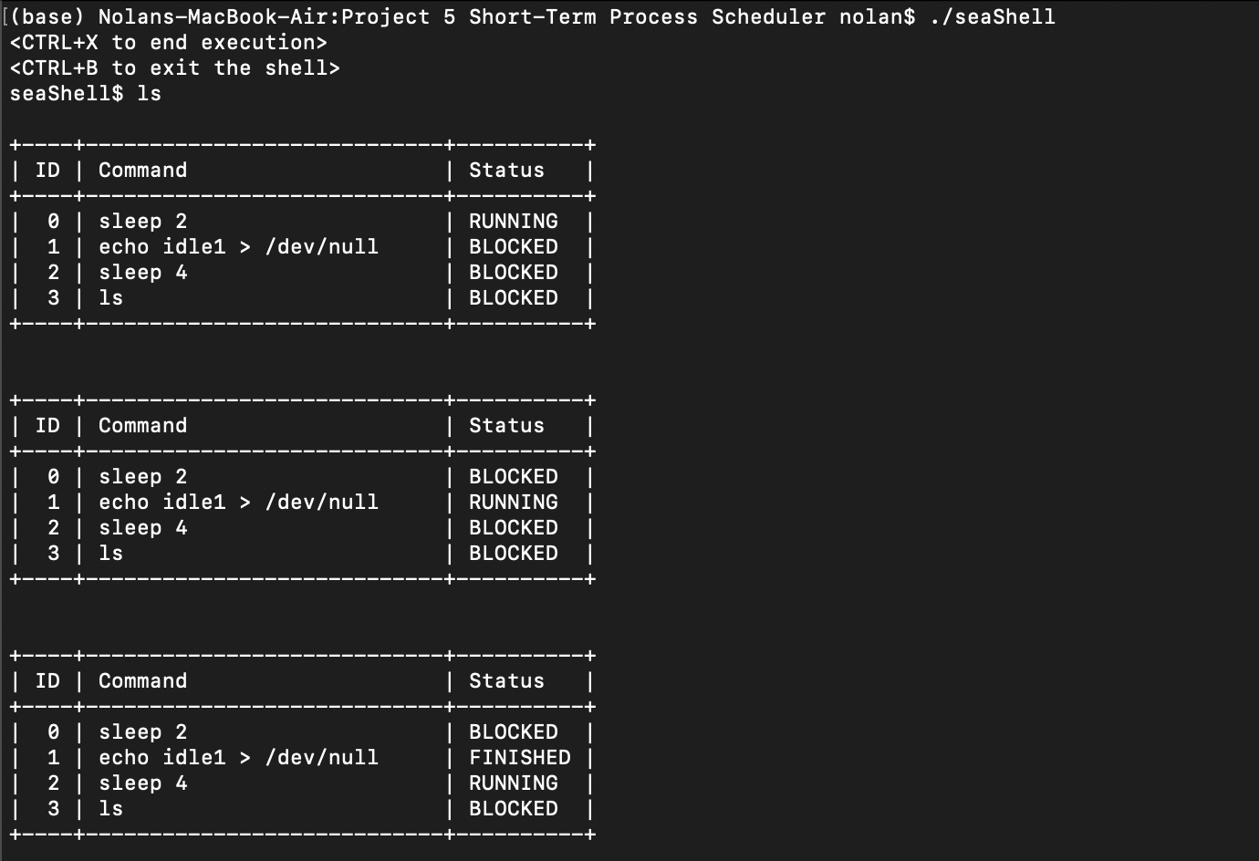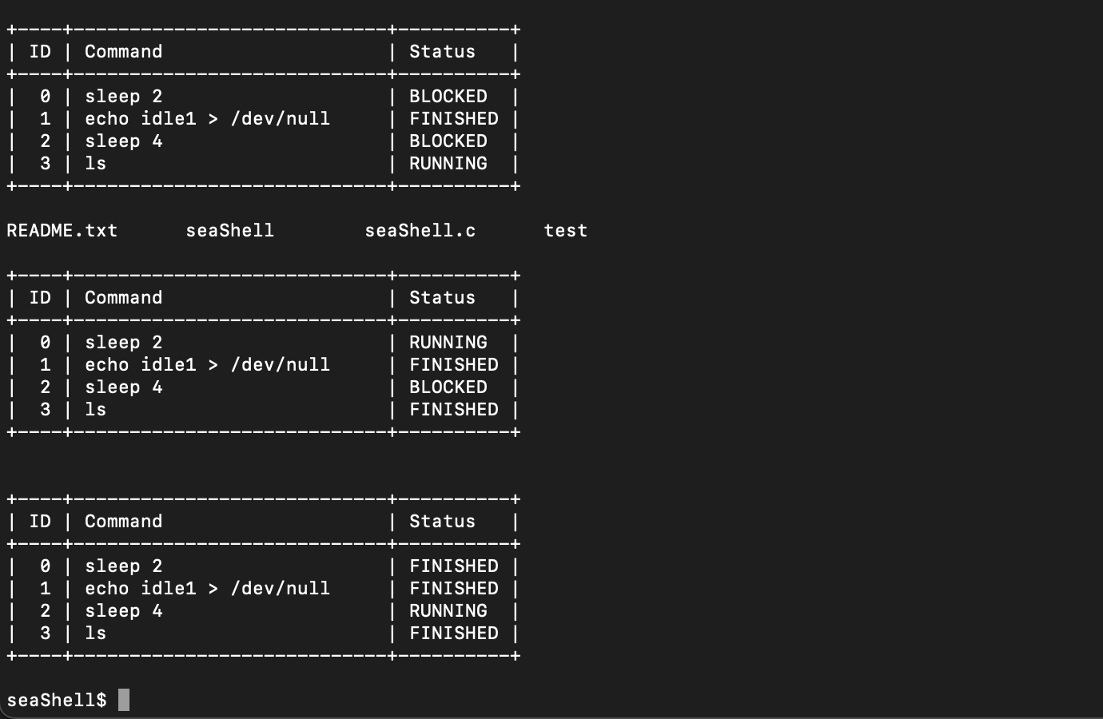
Running the ‘ls’ command. Notice how it only runs when the dispatcher reaches it in the queue, every process before must receive its time quantum first.
Scheduling Algorithm Choice
The Round-Robin scheduling approach is great for time-sharing systems and offers some improvements over other scheduling algorithms. This is because unlike First-Come First-Served (FCFS) scheduling, if for some reason a very lengthy process ends up first in the queue, it will not slow down the other processes since the dispatcher will switch after the time quantum has expired. For Shortest process next (SPN) scheduling, this is not an issue, however it may prove difficult to implement as it requires processes to declare how much time they will need before entering the queue or for an estimate to be available. Also, there is a risk of starvation of longer processes with SPN, if the shortest jobs being queued up complete and reenter the queue before the longer processes can be queued up, the longer processes will not be serviced and remain in the queue for a long time. However, a big disadvantage of Round-Robin scheduling is the overhead it generates, since it must generate an interrupt at periodic intervals, usually dependent on the clock (Stallings, 2019). Another possible disadvantage is poor service for I/O bound processes. Since I/O bound processes tend to have a shorter processor burst, which is the time between I/O executions, than processor-bound processes, they might not receive a fair portion of the time quantum (Stallings, 2019). If a processor-bound process gets its time quantum, executes using the full quantum and re-enters the queue whereas an I/O bound one will be blocked because of I/O operations before entering the queue again, the processor-bound process will be able to exit and enter the queue much more often, receiving much more of the time quantum.

Parameter Adjustment
We implemented an adjustable time quantum, allowing use of a system call to change the quantum of the short-term scheduler. Interesting effects occur when adjusting this parameter, for example when the time quantum is large enough that all processes are completed in 1 time quantum or less, it degrades into FCFS (Stallings, 2019). However, if the time quantum is extremely small, this will result in many more context switches for the dispatcher to perform, drastically increasing overhead. The optimal time quantum is large with respect to the context switch time, for example if the context switch time is 10 percent of the time quantum, approximately 10 percent of the CPU time will be spent on context switches (Stallings, 2019). As a rule of thumb, 80 percent of CPU bursts should be shorter than the time quantum (Stallings 2019). Measuring the effectiveness of a Round-Robin scheduler can be done using turnaround time, which is the amount of time to execute a particular process. For example, using our ‘setquantum’ command, when the quantum is set to 1 second instead of the default 2 seconds, the idle process with ID 0 receives much slower service because it does not complete during the first round. The overhead is also much worse because instead of 4 context switches, there are 6 in this situation.
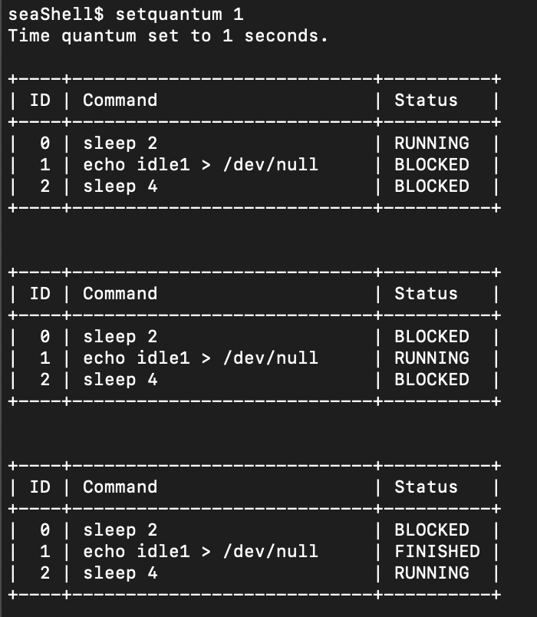
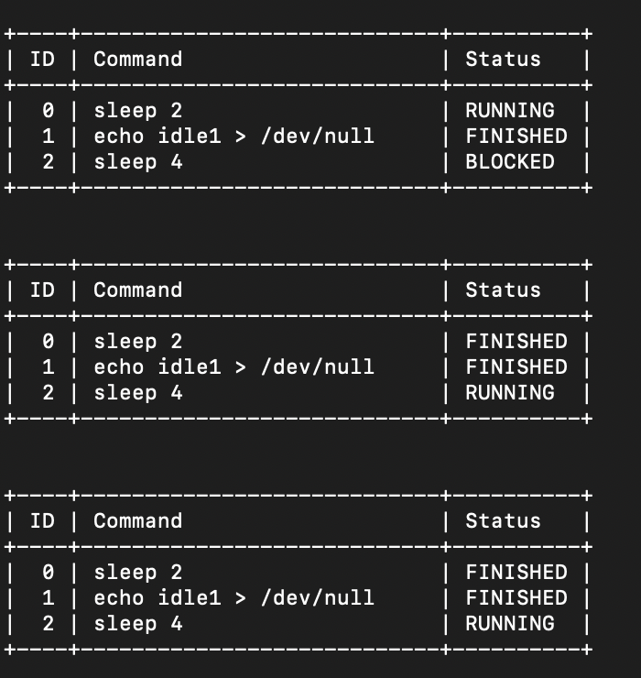
Setting the time quantum to 1 has the effect of increasing context switches, increasing overhead.
Data Observations
To further observe the effects that the time quantum has on our scheduler, we plotted the average turnaround time for each process when executing CPU bursts for four processes, ‘sleep 2’, ‘echo idle1 > /dev/null’, ‘sleep 4’, and ‘ls’. We tested this for time quantum ranging 1-5 and created the following graph:

This graph demonstrates that the most effective quantum (lowest average turnaround time) turned out to be 2 seconds in this scenario. Obviously, this depends heavily on the different processes doing CPU bursts because processes vary a lot in time required for execution, but with this measurement it is much clearer which time quantum should be used.

References
Stallings, W. (2019). Operating Systems: Internals and Design Principles (9th ed.). Pearson.
Tuttle, N., Hobson, M., (2025) CST315 GitHub. https://github.com/nolantuttle/CST315.git

